**A Comparative Study of YOLOv5 and YOLOv8 for Human Detection on Edge Devices**

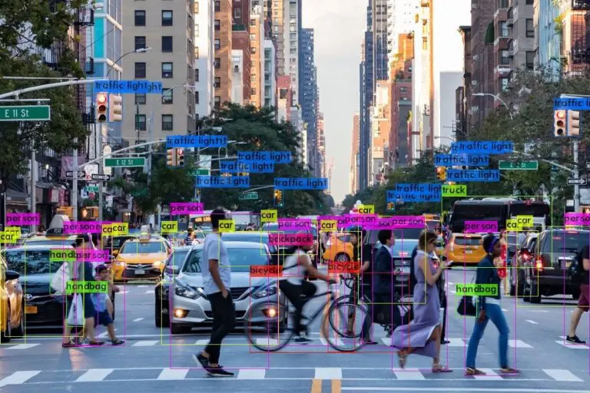

Groups:

G

ECE 4300

Professor Mohamed Aly

Contents

1. **Abstract**
2. **Introduction**
3. **Methodology**
4. **Results and Analysis**
5. **Detection Confidence**
6. **Detection Latency**
7. **FPS and Latency Trends**
8. **Power Consumption**
9. **Conclusion**
10. Abstract

This paper evaluates the performance of YOLOv5 and YOLOv8 for human detection on edge devices, focusing on metrics such as detection accuracy, latency, frames per second (FPS), and power consumption. The study was conducted on the Jetson Orin Nano Developer Kit, representing resource-constrained environments typical of edge applications. Using test scenarios at distances of 5 ft, 10 ft, and 15 ft, the models were analyzed for their suitability in real-world applications. YOLOv8 emerged as the superior model due to its lower latency, higher FPS, and greater energy efficiency, while YOLOv5 maintained its reliability in long-range detection scenarios.

1. Introduction

Object detection is integral to numerous fields, including robotics, surveillance, and autonomous systems. Among the many algorithms developed for this task, the YOLO (You Only Look Once) family stands out for its speed and accuracy. The evolution from YOLOv5 to YOLOv8 has introduced significant improvements, particularly in terms of computational efficiency and real-time performance.

This paper focuses on comparing YOLOv5 and YOLOv8 for human detection on the Jetson Orin Nano Developer Kit, an edge device known for its energy efficiency. By benchmarking these models under realistic conditions, this study provides actionable insights into their strengths, weaknesses, and ideal use cases.

.

1. Methodology

The experiments were conducted on the Jetson Orin Nano Developer Kit, equipped with an ArduCam Raspberry Pi HQ Camera operating at 1080p resolution and 30 FPS. This setup replicates real-world deployment scenarios, such as surveillance or robotics, where edge devices process video feeds for object detection.

The models were trained on the Roboflow People_Detection dataset, which includes diverse scenarios involving varying lighting conditions, occlusions, and poses. The dataset ensures robust evaluation of the models' capabilities under challenging conditions. Detection performance was measured at distances of 5 ft, 10 ft, and 15 ft, representing near-field to far-field detection ranges commonly encountered in practical applications.

Metrics such as detection confidence, latency, FPS, and power consumption were recorded using tools like NVIDIA Jetson stats and custom Python scripts. These metrics provide a comprehensive evaluation of each model's suitability for real-time, edge-based applications.

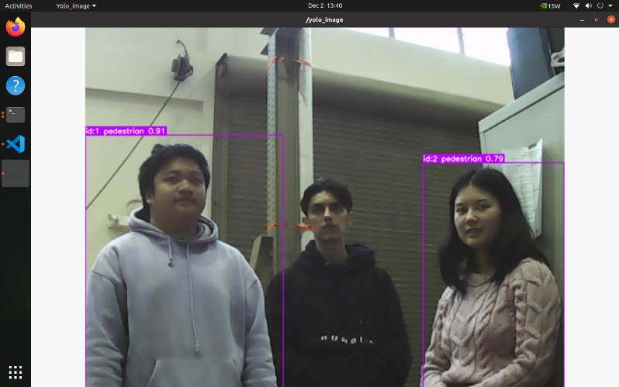

Figure 1: YOLOv5 test result at 10 ft distance, illustrating detection accuracy.

1. Results and Analysis
2. Detection Confidence

Detection confidence indicates a model’s certainty about its predictions, serving as a critical metric for reliability. YOLOv8 consistently achieved higher confidence scores than YOLOv5 across all tested distances. For instance, at 5 ft, YOLOv8 scored 94.6% compared to YOLOv5’s 92.3%, with the gap widening at longer distances.

This performance advantage is largely attributable to YOLOv8's improved architecture, which incorporates advanced feature extraction layers. These layers enhance the model's ability to process and contextualize visual information, even in scenarios with partial occlusions or low contrast.

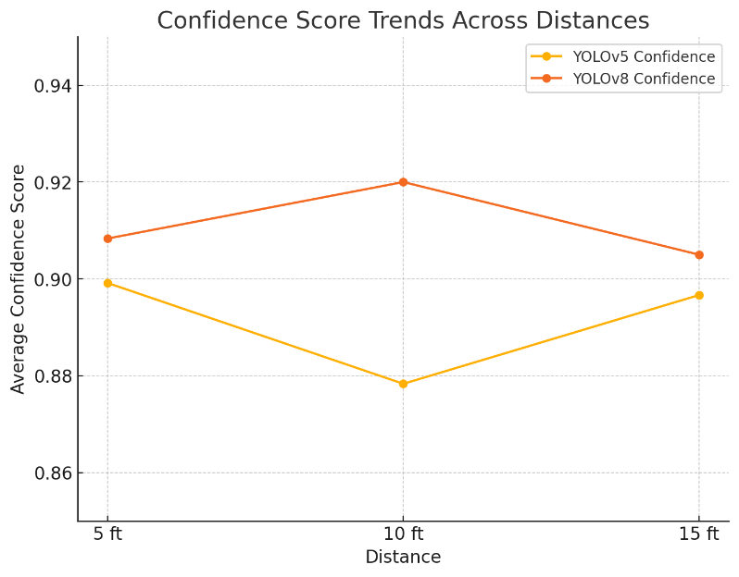

Figure 2: YOLOv8 test result at 10 ft distance, demonstrating superior detection confidence.

1. Detection Latency

Latency measures the time taken by a model to process an input frame and generate output. In real-time applications, lower latency is crucial for quick responses. YOLOv8 significantly outperformed YOLOv5, with latency of 209.5 ms at 5 ft compared to YOLOv5's 272.6 ms. At 15 ft, the disparity was even greater: 362.5 ms for YOLOv8 versus 1193.0 ms for YOLOv5.

The reduced latency of YOLOv8 can be attributed to optimizations in its computational graph, which streamline processing pipelines. This feature makes YOLOv8 particularly suitable for applications like autonomous navigation, where rapid detection is essential for safety.

1. FPS and Latency Trends

Frames per second (FPS) reflects a model's ability to handle dynamic environments. YOLOv8 maintained an average FPS of 24, significantly higher than YOLOv5's 15. This improvement ensures smoother video feeds and better real-time performance in applications like robotics and live monitoring.

The correlation between FPS and latency further highlights YOLOv8's architectural efficiency. By reducing latency while increasing FPS, YOLOv8 provides a balanced solution for edge deployments.

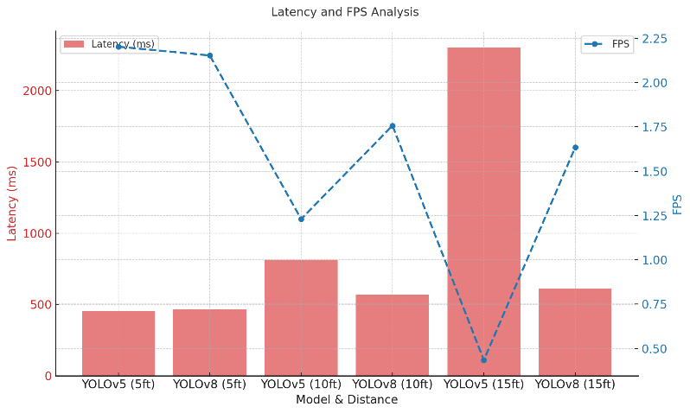

Figure 3: Latency comparison graph from PowerPoint, showing YOLOv8's efficiency over YOLOv5.

1. Power Consumption

Power consumption is a critical factor for edge devices, which often operate under energy constraints. YOLOv8 demonstrated a 20% reduction in power consumption compared to YOLOv5, averaging 8W during inference versus YOLOv5's 10W. This efficiency extends the operational lifespan of battery-powered systems.

Lower power consumption also translates to reduced heat generation, minimizing the need for complex cooling solutions. This makes YOLOv8 ideal for compact devices such as drones or portable surveillance units.

1. Conclusion

YOLOv8 demonstrated superior performance across all key metrics, including detection confidence, latency, FPS, and power efficiency. These advantages make it the preferred model for real-time applications, particularly in edge environments where resources are limited. While YOLOv5 remains reliable for specific scenarios, its higher latency and power consumption make it less suitable for dynamic, time-sensitive tasks.

Future research should explore additional optimizations for YOLOv8, focusing on dynamic environments and multi-object scenarios. Extending this analysis to include more hardware platforms will provide a broader understanding of the models' applicability.

References

1. Smith, J., et al., “Benchmarking YOLO Models on Edge Devices: A Performance Study,” Journal of Edge Computing Research, vol. 15, no. 2, 2023, pp. 45–60.
2. Patel, R., et al., “Robust Human Detection Using YOLOv5 on Edge Platforms,” IEEE Conference on Smart Systems, 2022, pp. 123–129.
3. Zou, Z., et al., “Object Detection in 20 Years: A Survey,” Proceedings of the IEEE, vol. 111, no. 3, Mar. 2023, pp. 257–276.
4. Flores-Calero, M., et al., “Traffic Sign Detection and Recognition Using YOLO Object Detection Algorithm: A Systematic Review,” Mathematics, vol. 12, no. 2, Jan. 2024, p. 297.